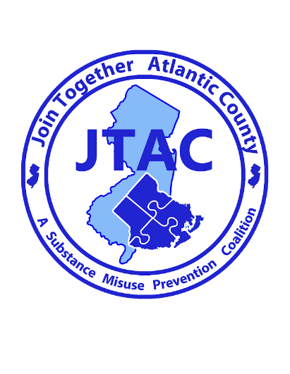

For Immediate Release

Contact: Nina Sciore
626 N Shore Rd
Absecon, New Jersey
Phone: (609) 272-0101 ext. 22
Email: nsciore@atlprev.org
Date: 3/10/2022
2023 Middle School Public Service Announcement Contest

Absecon, NJ- [3/10/2022] - Join Together Atlantic County, a countywide substance misuse prevention coalition, is holding an underage drinking prevention middle school public service announcement contest for 6 - 8th graders in Atlantic County. Students are invited to create an 8.5 x 11-inch landscape direction, PSA, as a message to parents from youth about the dangers of underage marijuana or alcohol use or providing either substance to those under 21. The top three winners will receive prizes and the 1st place winner’s entry may be turned into a billboard.
The younger a person starts drinking, the more likely he or she is to have alcohol problems later in life. According to NIAAA, people who start drinking before the age of 15 are at a higher risk for developing alcohol use disorder later in their lives. The brain is still forming until the early twenties and teen drinking can cause permanent brain damage. If you really want to fit in, stay sober. Most young people do not drink alcohol. Providing alcohol to those under 21 is illegal and can result in up to 6 months jail time, up to a $1,000.00 fine, and a permanent criminal charge on your record if convicted.
Rules and regulations for the middle school PSA Contest can be found at www.jtacnj.org/news. Entries are due to the Atlantic Prevention Resources office at 626 N Shore Rd, Absecon, NJ 08201 or emailed to nsciore@atlprev.org no later than 4 p.m. on Friday, April 28, 2023. For more information, contact Nina Sciore @ (609) 272-0101 ext. 22 or nsciore@atlprev.org.
By participating in this contest, youth help to support Join Together Atlantic County in their mission: “to prevent, reduce and/or delay substance use among youth of Atlantic County in a long term and sustainable manner.” Join Together Atlantic County is located at 626 N. Shore Road in Absecon, NJ.

###

