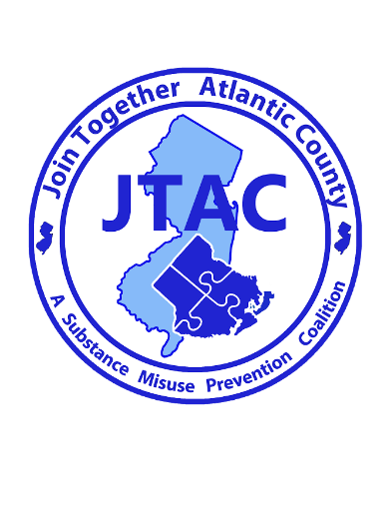

For Immediate Release

Contact: Brian J. Wilson
626 N Shore Rd
Absecon, New Jersey
Phone: (609) 272-0101 ext. 22
Email: Bwilson@atlprev.org,
Date: 01/29/2021
Hamilton Township Police Department Acquires Permanent Prescription Drop Box

Local Police Department Helps Combat Prescription Drug Misuse by Offering Safe Drug Disposal
Mays Landing, NJ- 01/29/2021 Join Together Atlantic County (JTAC), a substance misuse prevention coalition has partnered with Hamilton Township Police Department(Atlantic County) helping them secure a permanent prescription drop box for the public to dispose of unused, unwanted, and expired medications. The box is located inside the police department at 6101 13th St, Mays Landing, NJ 08330. It will be available to the public 24/7.

Hamilton Township Police Departments Chief Ciambrone and Det. Armitage along with Join together Atlantic Counties, Brian J. Wilson have worked eagerly to provide this much needed service to the local community.

Chief Ciambrone is pleased to be able to work with community outreach organizations, such as Join Together Atlantic County (JTAC) in order to provide resources that assist in reducing the misuse of prescription medication. He stated the police department has previously participated in the DEA National Prescription Drug Take Back Day events and we recognized the need to continuously assist our residents in properly deposing of unused medications. Wilson stated that properly securing and disposing of your medications are important steps in helping to prevent the theft and diversion of powerful opioid medications. Wilson also stated that safely securing and properly disposing of medication is key in helping to extinguish this opioid epidemic.

Permanent drop boxes and the awareness campaigns surrounding them are an important part of reducing the misuse of prescription medication. 2 in 5 teenagers believe prescription drugs are “much safer” than illegal drugs. Every day in the U.S. 2,500 youths take a prescription pain reliever for the purpose of getting high for the first time. Cleaning out medicine cabinets will reduce the number of prescriptions available for abuse. Wilson commends Chief Ciambrone and Det. Armitage and the entire Hamilton Township Police Department for taking the initiative to help protect our environment and keep our communities safe by offering the public a safe way to dispose of their medications preventing accidental poising and substance misuse.

The prescription drop box was purchased by JTAC with funds through New Jersey Department of Human Services, Division of Mental Health and Addiction Services. For more information about JTAC please visit www.jtacnj.org or call 609-272-0101 ext. 22.

JTAC challenges you to take the Five-Step American Medicine Chest Challenge:
• Take inventory of your prescription and over-the-counter medicine.
• Secure your medicine chest.
• Properly dispose of your unused, unwanted, and expired medicine.
• Take your medicine(s) exactly as prescribed.
• Talk to your children about the dangers of prescription drug abuse.

