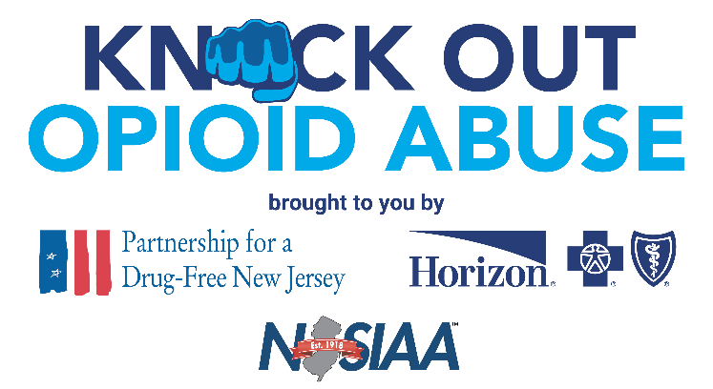

FOR IMMEDIATE RELEASE: May 22, 2023
Contact: Matt Birchenough, 201-916-1032, matt@drugfreenj.org

***MEDIA ADVISORY***
Former NFL Quarterback Ray Lucas to Discuss Addiction and Recovery with Oakcrest High School Student-Athletes

WHAT: The Partnership for a Drug-Free (PDFNJ) and Horizon Blue Cross Blue Shield of New Jersey, in collaboration with the New Jersey State Interscholastic Athletic Association (NJSIAA), will bring their Knock Out Opioid Abuse initiative to student-athletes of Oakcrest High School. The event is the final one in a series of 10 events to be held for high schools throughout the state through the end of the 2022-23 school year. The event is being held in collaboration with Atlantic Prevention Resources and Join Together Atlantic County.
WHEN: 9 – 10 a.m. Tuesday, May 23
WHERE: Oakcrest High School, 1824 Dr. Dennis Foreman Drive, Mays Landing, N.J.
WHO: Former NFL quarterback Ray Lucas will be the headline speaker at the event. Lucas starred at Rutgers University in the 1990s before embarking on an eight-year career in the NFL. Football took its toll on Lucas, who sustained numerous injuries and underwent more many surgeries during and after his playing career. He became dependent on prescription opioids, at times taking more than 1,400 pills a month. He has been open about his addiction and recovery in an effort to help others who have struggled with addiction and to prevent youth athletes from misusing and becoming addicted to opioids.
WHY: Student-athletes have an elevated risk of opioid use as sports injuries send more than 2.6 million children to emergency rooms every year, according to the Centers for Disease Control and Prevention. The mission of this event will be to educate student-athletes on the risks of prescription opioids and alternative treatments that exist, as well as the importance of taking care of themselves physically and mentally.
A Monitoring the Future survey also found that adolescent participants in high-injury sports had 50 percent higher odds of nonmedical use of prescription opioids than adolescents who did not participate in these types of sports.
As New Jersey’s opioid epidemic continues to plague the state, it is vital to reach student-athletes and educate them about the dangers of prescription opioids. In 2022, more than 2,800 people in New Jersey died of a drug overdose, a majority of which involved some form of opioid.

*Interviews available upon request.

Partnership for a Drug-Free New Jersey: Best known for its statewide substance use prevention advertising campaign, the Partnership for a Drug-Free New Jersey is a private not-for-profit coalition of professionals from the communications, corporate and government communities whose collective mission is to reduce demand for illicit drugs in New Jersey through media communication. To date, more than $200 million in broadcast time and print space has been donated to the Partnership’s New Jersey campaign, making it the largest public service advertising campaign in New Jersey’s history. Since its inception, the Partnership has garnered 217 advertising and public relations awards from national, regional and statewide media organizations.
About Horizon Blue Cross Blue Shield of New Jersey: Horizon Blue Cross Blue Shield of New Jersey, the state's oldest and largest health insurer is a tax-paying, not-for-profit health service corporation, providing a wide array of medical, dental, vision and prescription insurance products and services. Horizon BCBSNJ is leading the transformation of health care in New Jersey by working with doctors and hospitals to deliver innovative, patient-centered programs that reward the quality, not quantity, of care patients receive. Learn more at www.HorizonBlue.com. Horizon BCBSNJ is an independent licensee of the Blue Cross and Blue Shield Association serving more than 3.4 million members.

About The Horizon Foundation for New Jersey: The Horizon Foundation for New Jersey is committed to working alongside those who can help us improve our neighbors’ health, inform their health decisions and inspire them to lead healthier, more fulfilling lives. The Foundation’s funding pillars are Caring, Connecting and Creating. Horizon Blue Cross Blue Shield of New Jersey is the sole member of The Horizon Foundation for New Jersey, both of which are independent licensees of the Blue Cross and Blue Shield Association. For more information, please visit www.Horizonblue.com/Foundation
About the NJSIAA: Established in 1918, the New Jersey State Interscholastic Athletic Association (NJSIAA) is a voluntary, non-profit organization comprised of 436 accredited public and non-public high schools. A member of the National Federation of State High School Associations, the NJSIAA conducts tournaments and crowns champions in 33 sports. Championship competition for girls is sponsored in basketball, bowling, cross country, fencing, field hockey, golf, gymnastics, lacrosse, soccer, softball, swimming, tennis, outdoor track, winter track, volleyball, and wrestling. Boys’ championships are determined in baseball, basketball, bowling, cross country, fencing, football, golf, ice hockey, lacrosse, soccer, swimming, tennis, outdoor track, winter track, volleyball, and wrestling.

