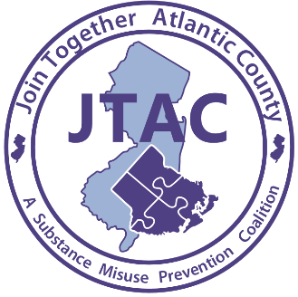

For Immediate Release
Contact: Laurie Smith
626 N Shore Rd
Absecon, New Jersey
Phone: (609) 272-0101 ext. 11
Email: Lsmith@atlprev.org
Date: 2/2/2021
Videos Released for Athlete and Opioid Misuse Prevention:
Helping guide and raise awareness of opioid use among student athletes

Absecon, 2/2/2021 - Join Together Atlantic County, a substance misuse prevention coalition, Atlantic Prevention Resources and the Atlantic County Opioid Task Force has made available prerecorded videos on the topic of preventing opioid misuse among athletes. The presentations are for high school athletes, their parents and guardians, as well as athletic directors, coaches, athletic trainers, and anyone else working with youth athletes. The videos are now available on the JTAC website: http://www.jtacnj.org/opioids-and-athletes.html There are five presentations recorded by local residents regarding their personal stories, experiences and perspectives on athletes and the dangers of opioid misuse. Presenters include: Dr. Josiah Bunting of Bunting Family Pharmacy; Sgt. Jennifer Cugini Atlantic County Prosecutor’s Office; Don Rogers Advanced Recovery Systems; Dave Sholler Philadelphia 76ers; and Melanie Mackleer with Atlantic Prevention Resources.

Youth athletes are at a higher risk for opioid addiction due to their greater risk of injury and their increased opportunity to receive diverted pain medications from teammates. Prevention outreach like these presentations will help educate the athletic community of these dangers.

The presentations were prerecorded allowing viewers to watch them in a virtual setting. Due to COVID-19, we were unable to provide the presentations in-person so the online videos were our next best option. Questions for the presenters can be submitted directly on the website and answers will be displayed at the bottom of the video page. We also have included an evaluation link on the website so viewers can provide feedback. Funding for the project was provided in part, by a grant from the New Jersey Department of Human Services, Division of Mental Health and Addiction Services.

Atlantic Prevention Resources is dedicated to preventing harm, caused by substance use and violence. Join Together Atlantic County, is a substance misuse prevention coalition whose goal is to prevent, reduce and or delay substance misuse among youth. For additional information please email Lsmith@atlprev.org or call (609) 272-0101 ext. 11.

###

