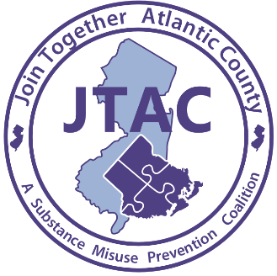

For Immediate Release
Contact: Laurie Smith
626 N Shore Rd
Absecon, New Jersey
Phone: (609) 272-0101 ext. 11
Email: Lsmith@atlprev.org
Date: 10/8/2020
Opioids: Taking Action in Our Community Today Radio Town Hall Meeting
Informative Conversation About Opioids and Actions Being Taken in Our Community
Absecon, NJ- 10/8/2020 Join Together Atlantic County and Atlantic Prevention Resources will be hosting a Radio Town Hall Meeting on the topic of opioids and prevention, treatment and recovery efforts in our community. The Radio Town Hall will take place on Tuesday, October 13th from 9:00AM until 9:50AM on WPG Talk Radio 1450 AM and 95.5 FM. Speakers will include Chief Bruce DeShields, Office of the Atlantic County Prosecutor, Angela Conover, Partnership for a Drug-Free New Jersey, Scott Gras, AtlantiCare Star Program, and Laurie Smith Atlantic Prevention Resources and will be moderated by Robert Zlotnick, Executive Director, Atlantic Prevention Resources and Harry Hurley, WPG Talk Radio.

The opioid epidemic and overdose crises have impacted everyone in our community. According to SAMHSA’s National Survey on Drug Use and Health, in 2018, approximately 10.3 million people aged 12 or older misused opioids in the past year. In addition, approximately 2.1 million people aged 12 or older had an opioid use disorder (SAMHSA). To learn more about the different prevention, treatment and recovery initiatives throughout Atlantic County, and surrounding area, and to ask questions be sure to tune into our Radio Town Hall.

To attend the Radio Town Hall Meeting click on the following link https://wpgtalkradio.com/and then click “Listen Now” on the top right of the page. Listeners can call in with questions and/or comments by dialing (609)407-1450. Atlantic Prevention Resources is dedicated to preventing harm, caused by substance use and violence. Join Together Atlantic County, is a substance misuse prevention coalition whose goal is to prevent, reduce and or delay substance misuse among children. This coalition project is funded by a grant from ONDCP (Office of National Drug Control Policy). For additional information please email Lsmith@atlprev.org or call (609) 272-0101 ext. 11.

###

