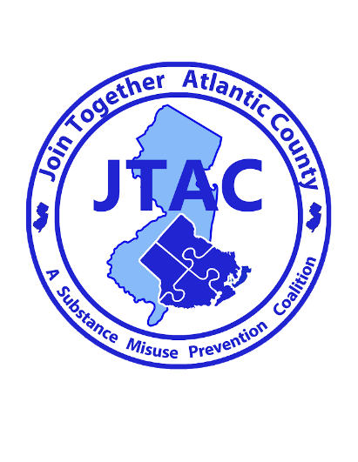

For Immediate Release

Contact: Amber Cutano
626 N Shore Rd
Absecon, New Jersey
Phone: (609) 272-0101 ext. 271
Email: acutano@atlprev.org
Date: 10/6/2020
Knock Out Opioid Abuse Day
“Join Together Atlantic County is working to help Knock Out Opioid Abuse in Atlantic County”
Absecon, NJ- [10/6/2020] - Join Together Atlantic County (JTAC), a countywide substance misuse prevention coalition, is participating in the fifth annual statewide Knock Out Opioid Abuse Day, organized by the Partnership for a Drug-Free New Jersey (PDFNJ).
Knock Out Opioid Abuse Day, held today, October 6 throughout the state, increases awareness of the opioid crisis through a mobilization effort with a focus on educating physicians and raising awareness among New Jersey residents and families. It is designed to inform residents and health care providers on the steps they can take to stem the epidemic.
JTAC has also shared information and resources from PDFNJ with Athletic Directors, Faith Based Leaders and coalition members to help spread awareness about this initiative in Atlantic County. JTAC has partnered with municipalities throughout the county to enact Proclamations recognizing October 6th as Knock Out Opioid Abuse Day. As of this date, Buena Vista Township, Egg Harbor City, Egg Harbor Township, Town of Hammonton, City of Linwood, Borough of Longport, City of Margate, Mullica Township, City of Northfield have all enacted Proclamations and additional towns will be forthcoming.
This year’s event, due to the COVID-19 pandemic, will take place almost exclusively in a virtual format on social media and through webinars and other learning opportunities.
In 2019, more than 3,000 people in New Jersey died of a drug overdose, a majority of which involved some form of opioid. These deaths include those who overdosed on heroin, prescription opioids and synthetic opioids, such as fentanyl.
Knock Out Opioid Abuse Day is a project of the Partnership for a Drug-Free New Jersey, in cooperation with the Governor’s Council on Alcoholism and Drug Abuse; the New Jersey Department of Human Services, Division of Addiction Services; and the Community Coalition for a Safe and Healthy Morris, with help from thousands of volunteers across the state. The New Jersey Senate and General Assembly has supported the event unanimously approving joint legislation designating October 6 as Knock Out Opioid Abuse Day in New Jersey.

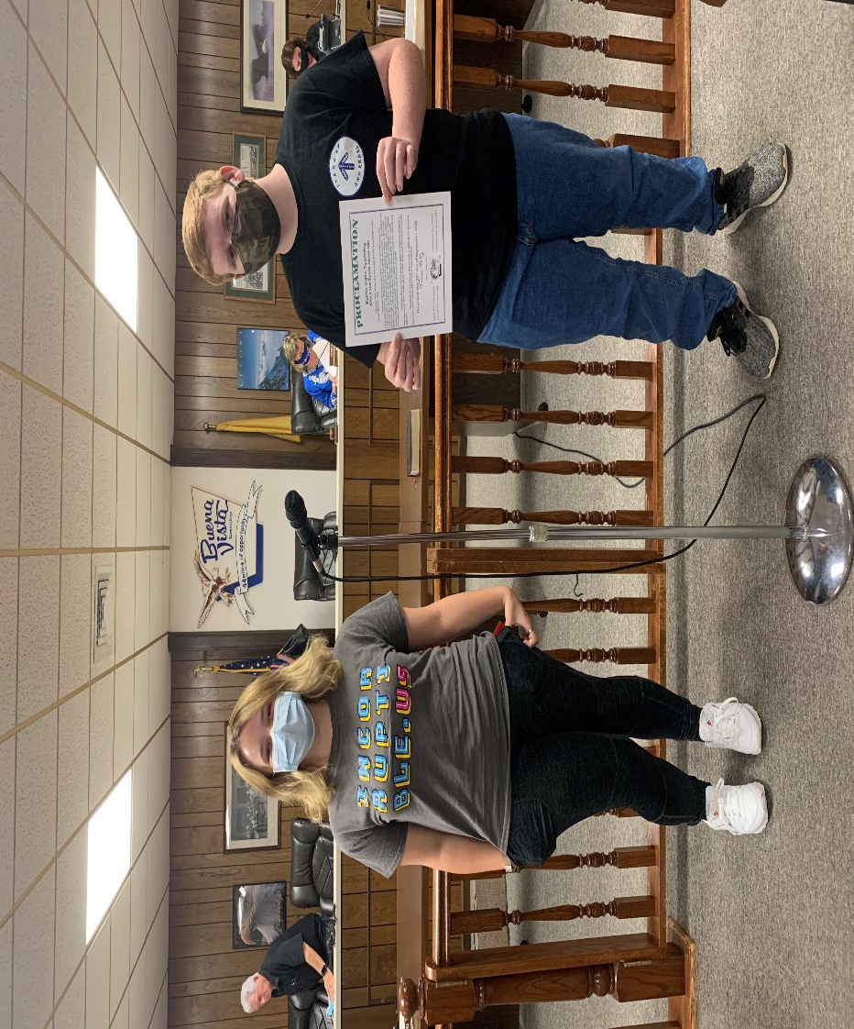
Katherine Jaques and Thomas Egan from Buena Regional High School and our youth coalition (Stand Up and Rebel) attended the Buena Vista Township committee meeting to have the Proclamation enacted and spoke briefly about what they have been doing to address substance misuse in Atlantic County.
###

